



PROJECT PRE-REQUISITES
Before the commencement of our project, we were required to complete courses in various domains and topics. During this training period, we learnt and gained experience and proficiency in the following topics:
- Operating Systems and UNIX
- Computer Networks and Cloud Computing
- HTML, CSS, JavaScript, ES6 Standards and TypeScript
- React and Redux Toolkit – Functional & Class-based Components, Routing, Hooks, Context API, Redux Store, Development and Production
- NextJS – CSR, SSR, SSG, ISR, Routing, APIs, Authentication
- Quality Assurance – STLC, Testing Techniques, SOAP and REST APIs, Postman, Test Case Documentation, Defect Documentation
PROJECT ABSTRACT
In today's fast-paced business environment, organizations need a comprehensive tool to manage their teams and ensure effective communication and collaboration. A web platform that can show all the teams in an organization with individual team's activities, issues, ideas, and discussions is an essential tool for any modern organization.
Such a web platform provides a centralized location for team members to collaborate, communicate, and share information. It helps to create a sense of community among team members and enables them to stay connected even when they are not physically together. The platform can be accessed from anywhere and at any time, making it a highly convenient tool for remote teams.
In summary, Infobuzz is a web platform that shows all the teams in an organization with individual team's activities, issues, ideas, and discussions is an essential tool for modern organizations. It promotes knowledge sharing, collaboration, innovation, transparency, and accountability. By using such a platform, organizations can ensure effective teamwork, streamline communication, and improve productivity.
Introduction
AT&T Overview
AT&T is a multinational telecommunications corporation that provides a range of services, including wireless voice and data, broadband internet, and digital television. The company was founded in 1983 and is headquartered in Dallas, Texas. It is one of the largest providers of mobile and fixed-line telephone services in the United States, with a presence in over 200 countries worldwide.
Problem Definition
In today's fast-paced business environment, organizations need a comprehensive tool to manage their teams and ensure effective communication and collaboration. A web platform that can show all the teams in an organization with individual team's activities, issues, ideas, and discussions is an essential tool for any modern organization.
Such a web platform provides a centralized location for team members to collaborate, communicate, and share information. It helps to create a sense of community among team members and enables them to stay connected even when they are not physically together. The platform can be accessed from anywhere and at any time, making it a highly convenient tool for remote teams.
One of the primary benefits of such a platform is that it helps to promote knowledge sharing across the organization. When all teams' activities, issues, and ideas are visible in a centralized location, it becomes easier for team members to learn from each other and avoid duplicating efforts. This promotes efficiency and productivity across the organization.
The web platform can also be a powerful tool for tracking progress and identifying issues that need to be addressed. Managers can use the platform to monitor their team's activities and identify areas where they can improve. They can also use it to provide feedback and guidance to team members.
Moreover, the platform can be used to promote innovation and collaboration. Team members can use it to share their ideas and collaborate on new projects. They can also use it to provide feedback on existing projects and make suggestions for improvement.
In addition to these benefits, the web platform can also be used to promote transparency and accountability. When all team members' activities and discussions are visible to everyone in the organization, it becomes easier to hold team members accountable for their work and ensure that everyone is working towards the same goals.
In summary, we require a web platform that shows all the teams in an organization with individual team's activities, issues, ideas, and discussions is an essential tool for modern organizations. It promotes knowledge sharing, collaboration, innovation, transparency, and accountability. By using such a platform, organizations can ensure effective teamwork, streamline communication, and improve productivity.
Objectives
Improved Collaboration: The primary objective of the web platform would be to improve collaboration and communication among teams within the organization. By providing a central hub for sharing information, updates, and ideas, the platform would facilitate cross-functional collaboration and help teams work more effectively together.
Enhanced Productivity: By providing teams with a centralized location to access and share information, the web platform would help to streamline workflows and improve productivity. Team members would be able to quickly find the information they need and collaborate with their colleagues in real-time, reducing the time and effort required to complete projects.
Increased Transparency: The web platform would help to promote transparency within the organization by providing visibility into each team's activities, issues, and ideas. This would help to build trust and accountability among team members and foster a culture of transparency and open communication.
Efficient Issue Resolution: The web platform would also help teams to more efficiently resolve issues and challenges they encounter during projects. By providing a central location to document and track issues, team members could quickly identify and address problems, reducing the risk of delays and ensuring projects stay on track.
Better Knowledge Management: The web platform would also enable teams to better manage their knowledge by providing a central location to store and share documents, best practices, and other important information. This would help to ensure that valuable knowledge is not lost when team members leave or transition to other projects.

Features Implemented in Project
Next.js is a popular open-source framework for building server-rendered React applications. It is built on top of React and provides a powerful set of features that make it easy to build complex and highly performant applications. One of the main features of Next.js is server-side rendering (SSR). This means that Next.js generates the HTML and CSS for a web page on the server before sending it to the client's browser. This provides a number of benefits, including faster page load times, improved SEO, and better accessibility for users with slow internet connections or devices that don't support JavaScript.
Client-side rendering (CSR) is a web development technique that allows the user interface (UI) of web applications to be rendered on the client-side, i.e., in the user's web browser. This is in contrast to server-side rendering (SSR), where the UI is rendered on the server before being sent to the client's browser. CSR has become more popular in recent years due to the increased usage of modern web development frameworks like React, Angular, and Vue.js.
Server-side rendering (SSR) is a web development technique that allows the user interface (UI) of web applications to be rendered on the server before being sent to the client's web browser. This is in contrast to client-side rendering (CSR), where the UI is generated on the client-side using JavaScript. SSR has been a common web development technique for many years but has been gaining renewed interest in recent years with the rise of modern JavaScript frameworks like React and Vue.js.
JSON Web Tokens (JWTs) are a popular method of securely transmitting information between parties over the internet. A JWT is a string that consists of three parts: a header, a payload, and a signature. The header and payload are base64-encoded JSON objects, while the signature is used to verify the authenticity of the token.

Project Design
High Level Description
The website called Infobuzz can be designed using a client-server architecture, where the client is responsible for rendering the UI and interacting with the user, and the server provides the necessary data and processing logic.
On the server side, we can use a RESTful API to manage the teams, ideas, issues, and discussions. The API can be built using a framework like Node.js or Django and can provide endpoints for creating, reading, updating, and deleting data. We can also use a database like MySQL or MongoDB to store the data.
For the client-side rendering, we can use a modern frontend framework like React or Vue.js. When a user visits the dashboard, the client-side application can make an API request to fetch the list of teams and render the team cards on the page. On clicking a team card, the client-side application can make another API request to fetch the data for the team and render the team tab with its respective activities, issues, ideas, and discussions. The user can also add, edit, or delete ideas or issues, and provide feedback or comments.
To ensure security, we can use JSON Web Tokens (JWT) for authentication and authorization. When a user logs in, the server can generate a JWT containing the user's credentials and send it to the client. The client can then store the JWT in local storage and use it to make API requests to the server. The server can verify the JWT to ensure that the user is authorized to perform the requested action.
To allow the admin to add new teams, we can provide a separate admin dashboard that allows the admin to create a new team by entering its title, overview, and members list. The server can then store the team data in the database and make it available to the client-side application.
Overall, the system design of the Infobuzz website can be modular and scalable, allowing for easy addition of new features and functionalities in the future.
Process Flow
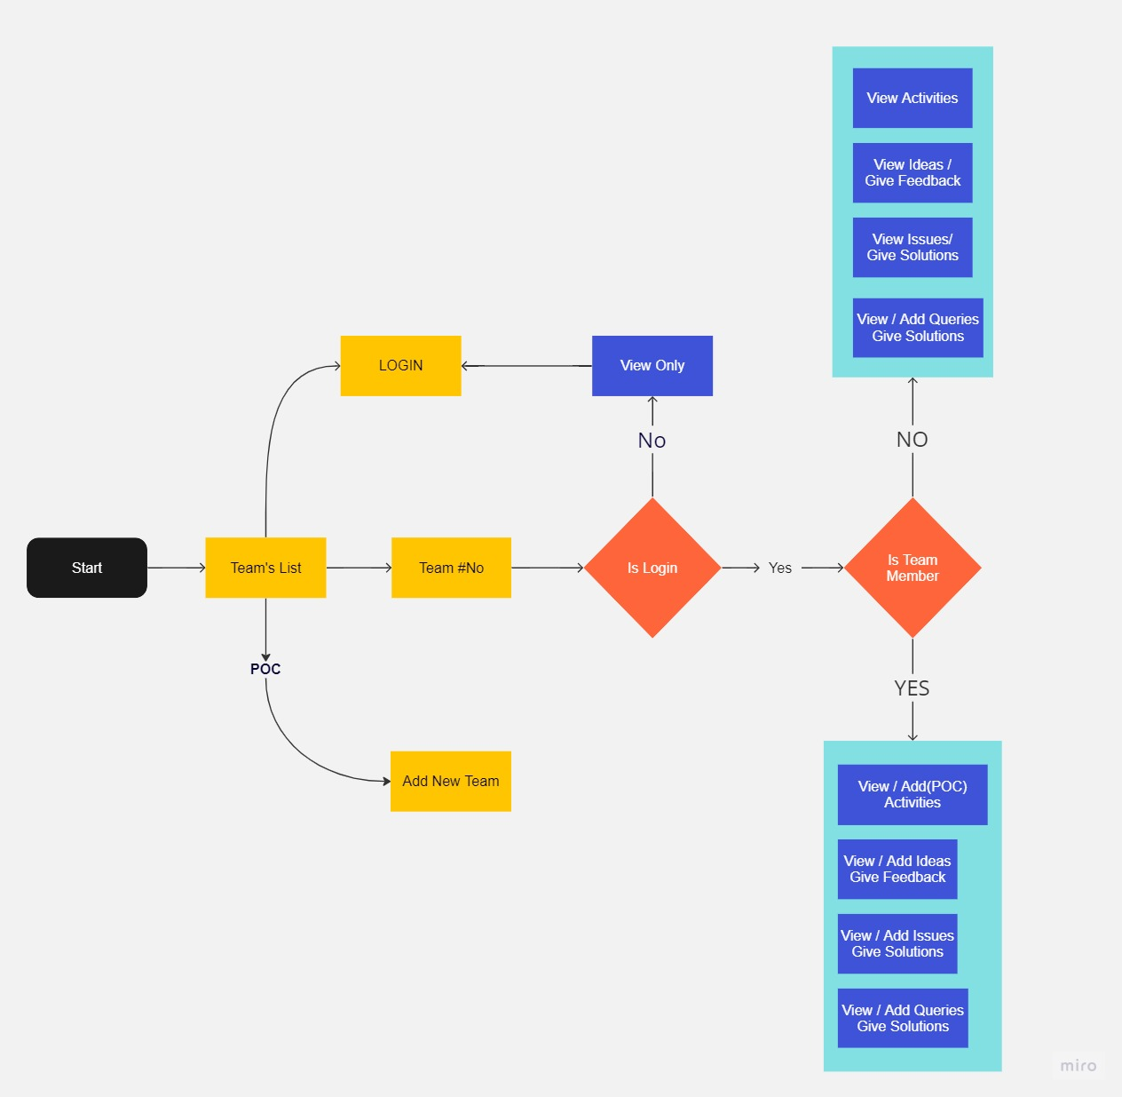
InfoBuzz process flow
The website called InfoBuzz is designed to allow users to view a dashboard of all the teams within an organization. This dashboard provides an overview of each team, including their activities, ideas, issues, and discussions. Upon clicking on a particular team card, the user is directed to the respective team tab where they can view detailed information about that team.
In the team tab, the user can add or edit ideas, issues, or discussions. The team leader has the privilege of adding new team members and assigning roles such as developer, tester, UI designer, and team leader. Each team member has the ability to add their ideas, issues, and discussions to their team tab. Additionally, team members can comment or provide feedback on the ideas and issues posted by their colleagues. The user also has the ability to delete the idea or issue or comment if they are the owner of it.
The system design of this website is centered around a client-server architecture. The client-side of the website is built using React.js, a popular JavaScript library for building user interfaces. React is used to create the interactive user interface of the website, allowing users to navigate between team cards and team tabs, and to add, edit, and delete ideas, issues, and discussions.
On the server-side, the website uses Node.js, a server-side JavaScript runtime environment, to handle HTTP requests and manage the database. The website also utilizes a popular Node.js framework called Express.js to build the REST API that is used to communicate between the client and server.
To manage user authentication and authorization, InfoBuzz uses JSON Web Tokens (JWTs). When a user logs in, the server generates a JWT, which is sent to the client and stored in the browser's local storage. The JWT contains a unique identifier for the user, as well as an expiration date. This allows the server to verify the identity of the user and determine what actions they are authorized to perform on the website.
The website also utilizes Next.js, a popular React framework for building server-side rendered (SSR) web applications. Next.js allows for faster page loading times and improved search engine optimization (SEO) by pre-rendering pages on the server and delivering them to the client as static HTML. This eliminates the need for the client to request data from the server on every page load, improving performance and user experience.
The database for InfoBuzz is built using MongoDB, a popular NoSQL database that stores data in JSON-like documents. The database is designed to store information about each team, including their activities, issues, ideas, and discussions, as well as information about each team member and their assigned roles.
To ensure the security of user data, InfoBuzz uses industry-standard encryption protocols such as SSL/TLS to encrypt data in transit, as well as hashing algorithms to encrypt sensitive data such as user passwords.
In summary, InfoBuzz is a web platform designed to provide an overview of an organization's teams and their activities, ideas, issues, and discussions. The system architecture of the website is centered around a client-server architecture, with the client-side built using React.js and the server-side built using Node.js and Express.js. User authentication and authorization are managed using JSON Web Tokens (JWTs), while the website utilizes Next.js for server-side rendering and MongoDB for database storage. The website is designed to be secure, utilizing encryption protocols to protect user data, and easy to use, allowing users to add, edit, and delete ideas, issues, and discussions within their respective teams.
Assumptions
Assumption 1: Each team has exactly one Point of Contact (PoC).
Assumption 2: A member can be part of only one team at a point of time.
Assumption 3: Team member should be logged in to add, delete and edit team content.
Assumption 4: Teams can only be created/ deleted by the Admin.
Assumption 5: Minimum size of a team at the time of creation is 1.

Results
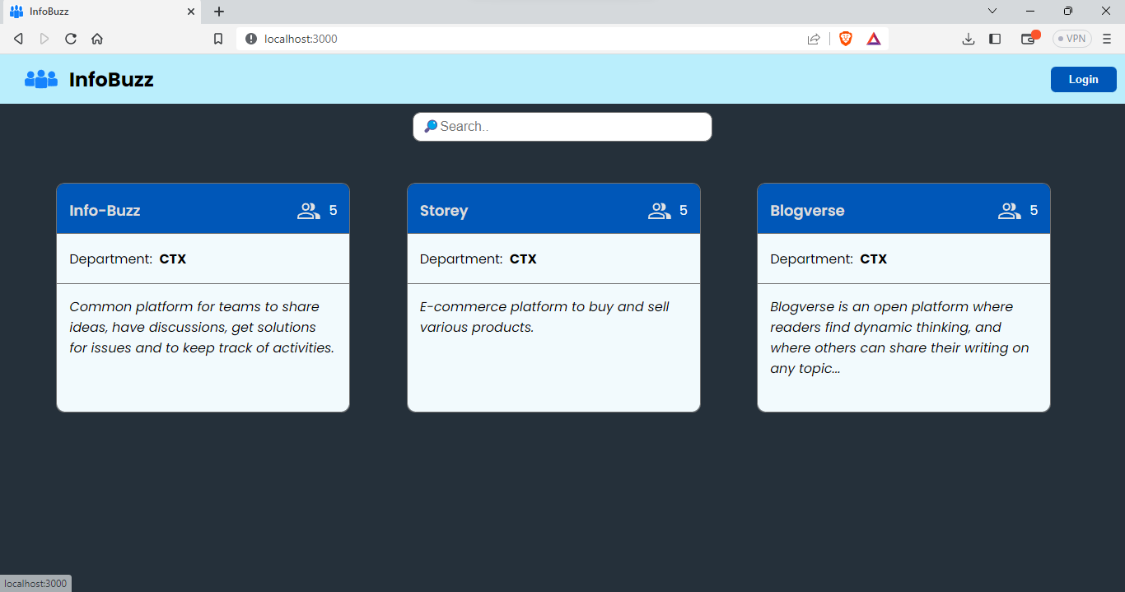Home Page
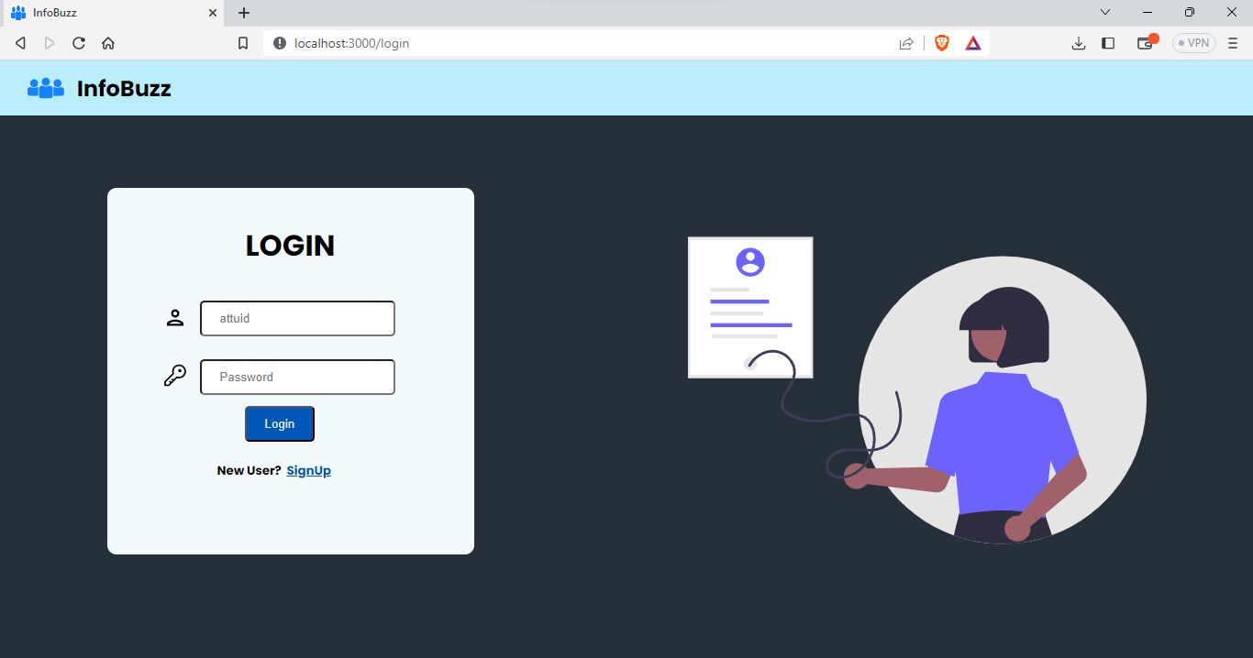Login Page
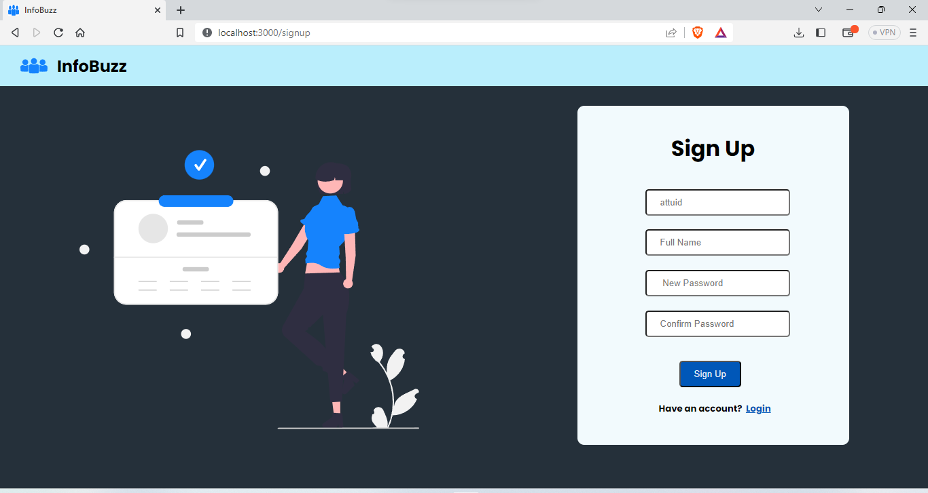Sign Up Page
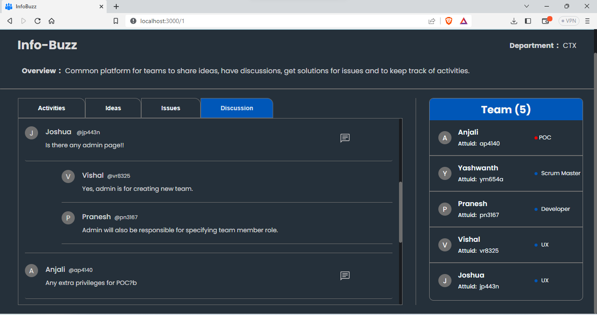Team Discussions
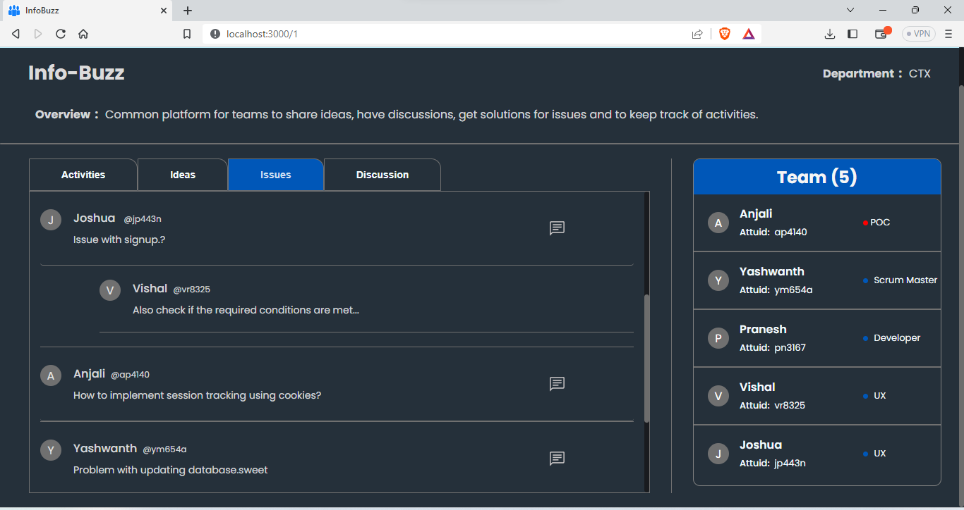Team Issues
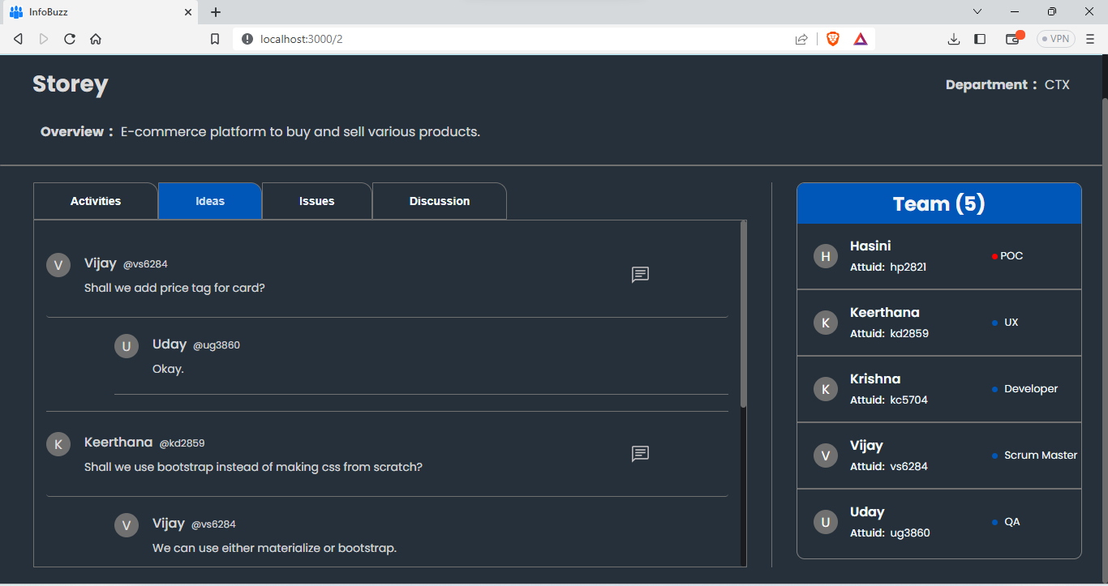Team Ideas
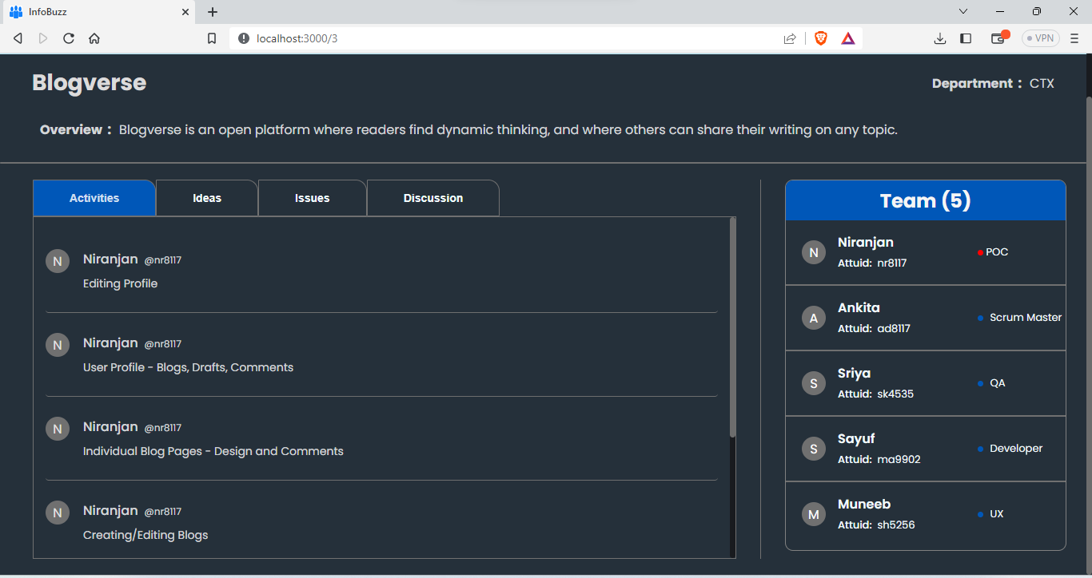 Team Activities
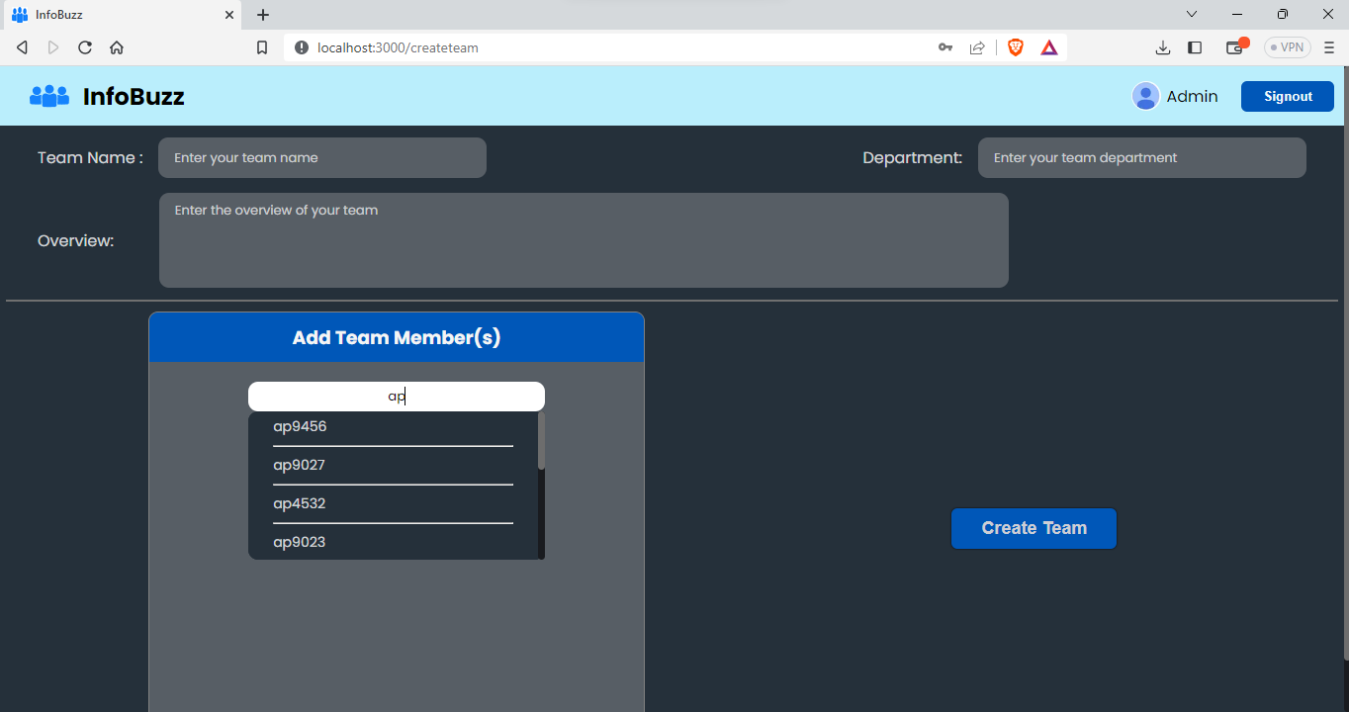Create Team as an Admin
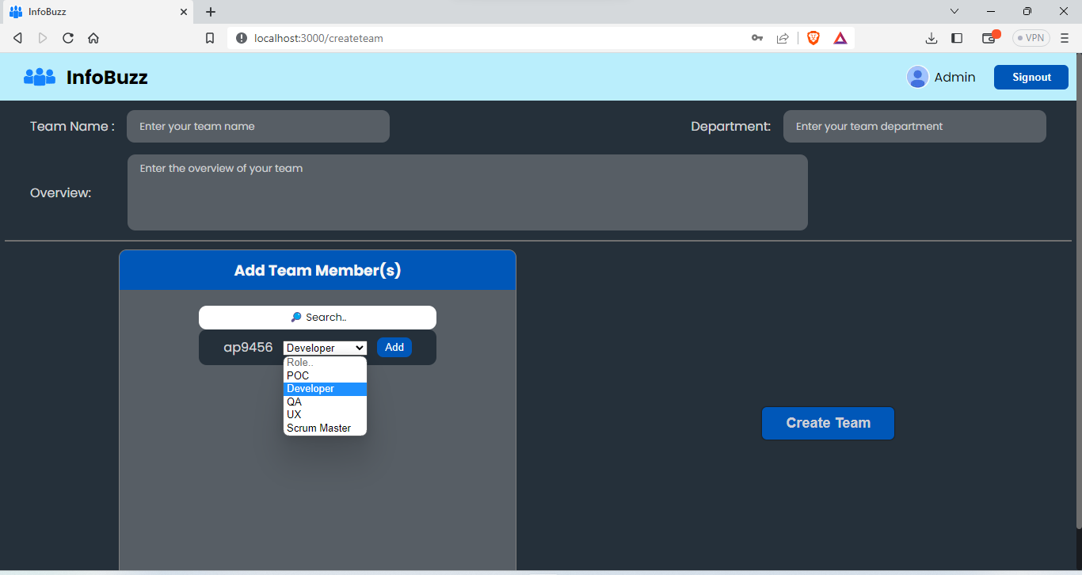Choose a designation for a team member as an admin
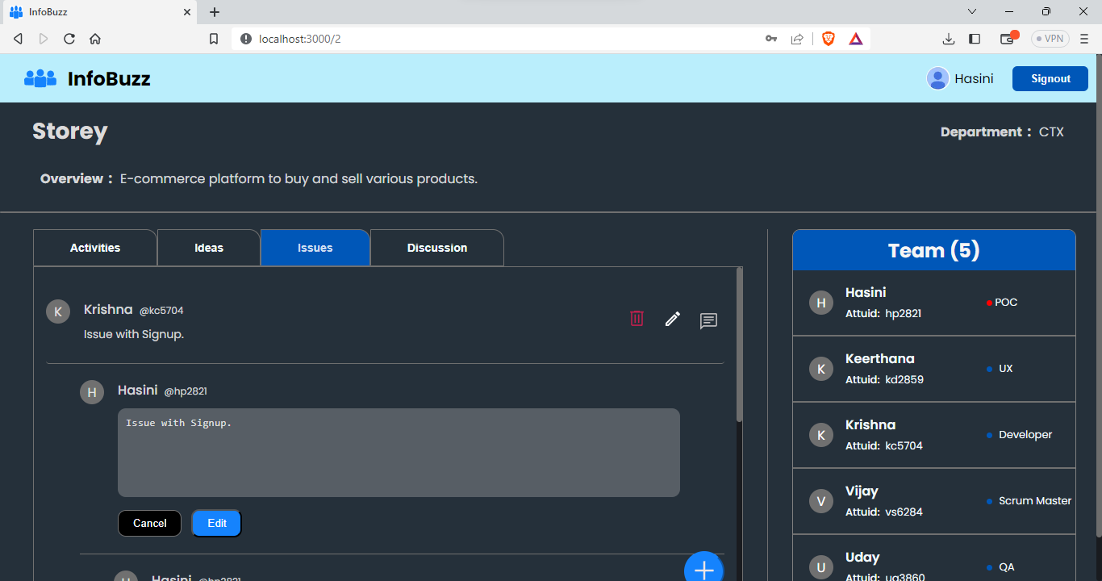Edit a comment as a PoC
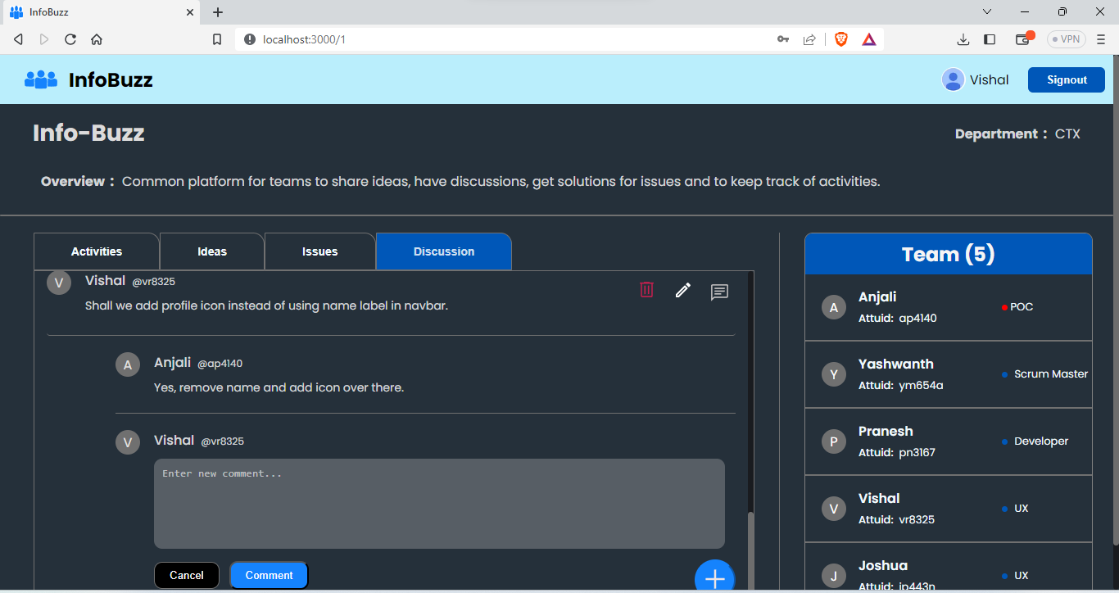Add a comment as a team member
Conclusion
In conclusion, Infobuzz is a powerful web platform that enables organizations to effectively manage their teams and their activities. By providing a centralized hub for tracking issues, sharing ideas, and facilitating discussions, Infobuzz promotes collaboration and transparency across the organization. With its intuitive interface and robust feature set, Infobuzz is a must-have tool for modern organizations looking to streamline their team management processes and enhance their overall productivity.

Vasavi College of Engineering (Autonomous)
(Affiliated to Osmania University)
Hyderabad-500 031
Department of Information Technology

Internship Project Report

Name: KVS Sriya
Roll Number: 1602-19-737-115
Organization: AT&T
External Guide: Dommeti Trinadh Praveen Kumar
Internal Guide: Ms. S. Aruna

